**HR ANALYTICS DASHBOARD**

**About project:**

Acme Corporation, a leading tech company, is facing a significant challenge with employee turnover. The HR department is concerned about the increasing rate of attrition, as it negatively impacts team dynamics, project continuity, and overall company morale.

**Objective:**

Understand the factors influencing employee turnover and predict which employees are likely to leave in the near future.

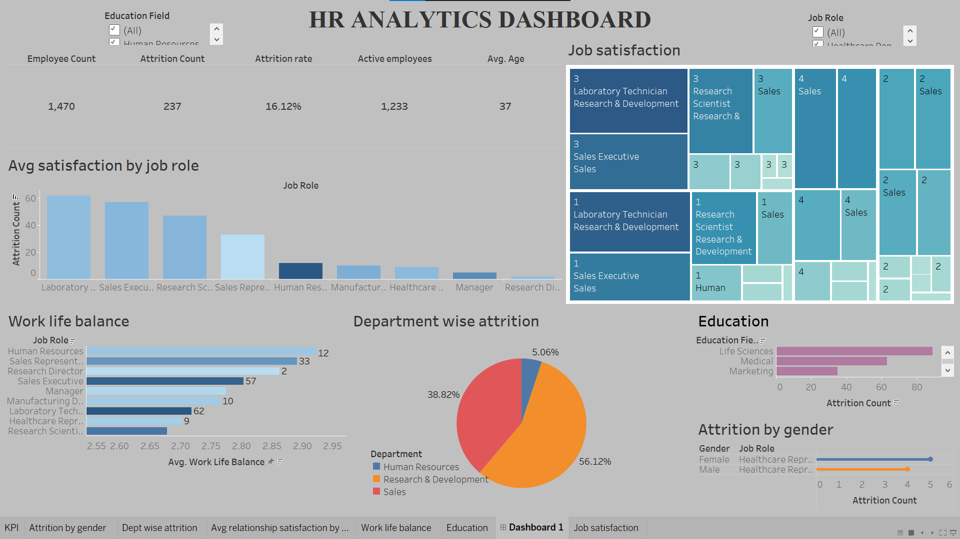

**My insights from the dashboard:**

1. **Gender:** Female has the highest number of attrition count.
2. **KPI:** So from here we get our total employee count and the attrition count 237 so we get the attrition rate as 16 %.
3. **Job satisfaction:** It tells us about the job role and the attrition count. We can see laboratory technician has the highest attrition count. So we need to hire there people. Also need to talk to them about their problems
4. **Avg. satisfaction by job role:** So here we can get the avg satisfaction and here too laboratory technician has highest number say 62.
5. **Work life balance:** Here we can see laboratory technician followed by sales executive in a horizontal bar chart.
6. **Department Wise Attrition:** Research and development department has 56% attrition count with laboratory technician job role.
7. **Education:** Life sciences has highest attrition count. So we can look out like there job may not be related to the field so we can aim to take less number of people from that field so that our attrition count gradually decreases.